SESSION-1 Defect Management, Bug Life Cycle, Priority & Severity
Q-1. Pick any mobile app you use daily (like Zomato, Instagram, or Paytm), open its login or signup form, and identify 5 possible defects in the UI or workflow. Write each defect as a clear defect statement.
Ans.
Application Chosen: Instagram
Module: Login / Signup Form
1. Password Visibility Icon Not Working
Defect Statement:
When the user taps the "Show Password" eye icon on the login screen, the password remains masked instead of becoming visible, preventing users from verifying their entered password.
2. Login Button Enabled with Invalid Email Format
Defect Statement:
The Login button remains enabled when an invalid email format (e.g., user@) is entered, allowing users to attempt submission without proper input validation.
3. Error Message Disappears Too Quickly
Defect Statement:
After entering incorrect login credentials, the error message disappears within a few seconds, giving users insufficient time to read and understand the issue.
4. Keyboard Covers Signup Button on Small Screens
Defect Statement:
On devices with smaller screen sizes, the on-screen keyboard overlaps the Signup button, making it inaccessible without manually scrolling the page.
5. Password Field Data Lost After Validation Error
Defect Statement:
When the user submits the signup form with a missing mandatory field, the application clears the password field instead of retaining the entered value, forcing the user to re-enter the password.
Q-2. For each defect you found in the previous task, assign a Severity level (Blocker, Critical, Major, Minor, Trivial) and a Priority level (High, Medium, Low). Briefly justify your choice for one defect where severity and priority are different. Think about how badly the defect impacts users (severity) versus how quickly it should be fixed (priority).
Ans.
Defect ID | Defect Description | Severity | Priority
D1 | Password visibility icon does not reveal the password when tapped. | Minor | Medium
D2 | Login button remains enabled for invalid email formats. | Major | High
D3 | Error message disappears too quickly after failed login attempt. | Minor | Low
D4 | Keyboard covers Signup button on small-screen devices. | Major | High
D5 | Password field is cleared after a validation error during signup. | Minor | Medium
Q-3. Draw a Bug Life Cycle diagram showing all the main states (New, Assigned, Open, Fixed, Retest, Verified, Closed, Rejected, Deferred, Duplicate, Not a Bug) and the transitions between them. You can use pen-paper and upload a photo, or use any diagram tool you like.
Ans.
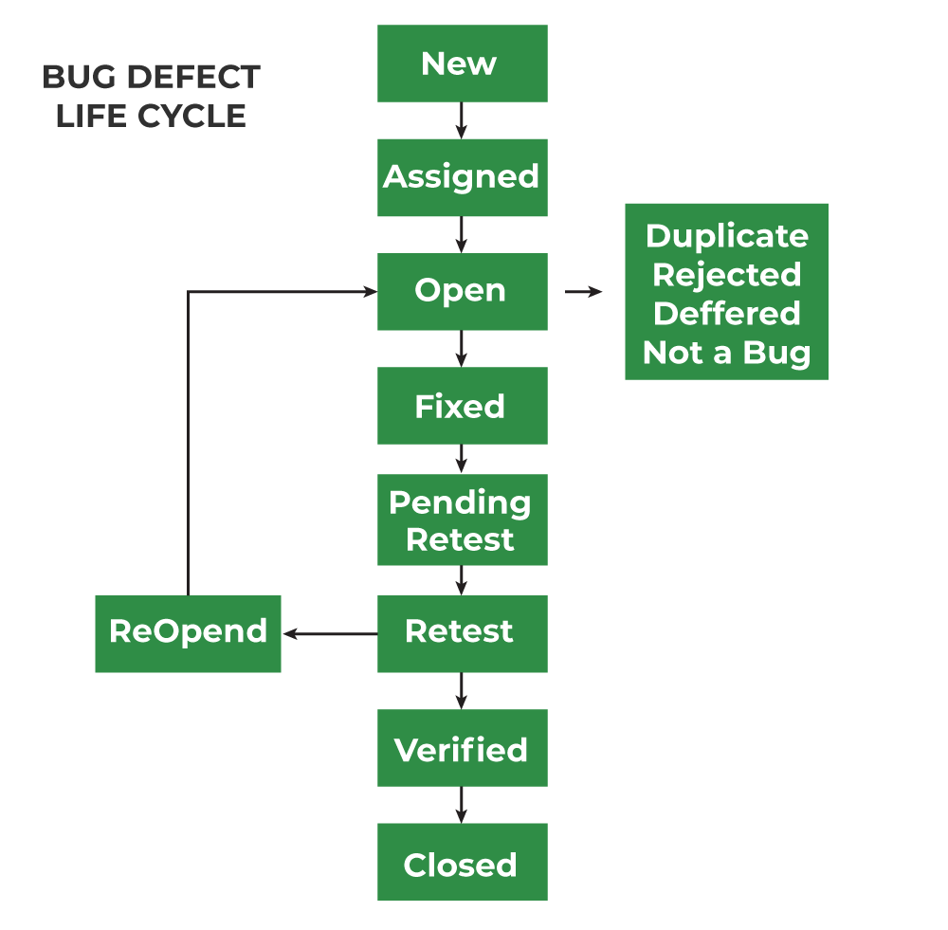
State | Description
New | Tester logs a new defect.
Assigned | Defect is assigned to a developer.
Open | Developer analyses the defect.
Fixed | Developer fixes the issue and updates the status.
Retest | Tester retests the fix.
Verified | Tester confirms the defect is resolved.
Closed | Defect is closed successfully.
Duplicate | Defect already exists in the system.
Deferred | Fix is postponed to a future release.
Not a Bug | Reported behaviour is expected and not considered a defect.
Q-4. Write a short scenario where a defect in a UPI payment feature (like in PhonePe or Paytm) is found very late—after the app is live. Explain in 4-5 lines how the cost and impact of fixing this defect would be different if it was caught during development instead.
Ans.
Scenario:
A UPI payment app similar to PhonePe or Paytm goes live. After deployment, users report that when a payment times out due to a network issue, the amount is deducted from their bank account, but the transaction status shows "Failed." Hundreds of users raise complaints, and customer support receives a large volume of refund requests.
If this defect had been identified during development or testing, the fix would have required only a code change and retesting, resulting in minimal cost. Since it was found after release, the company must investigate affected transactions, process refunds, deploy an emergency patch, and handle customer complaints. The financial cost, operational effort, and reputational damage are significantly higher than if the issue had been caught earlier in the SDLC.

